KHARMS, Daniil Ivanovich (ХАРМС, ДАНИИЛ ИВАНОВИЧ) (1905-42)

Co-founder (with Aleksandr VVEDENSKY) of the short-lived “Obedinenie real'nogo iskussta” or OBERIU (“The Association for Real Art”), Kharms was one of the leading figures of the Leningrad poetic avant-garde in the late 1920s and 1930s. Best known as the author of darkly-comic, absurd, and often violent prose miniatures, Kharms was unable to publish either his poetry or prose “for adults” during his lifetime, and survived by writing brilliantly inventive children’s verse beloved by several generations of Russian speakers. Both his poetry of the 1920s and his prose of the 1930s eschew logic and revel in nonsense on the premise that language was otherwise unable to convey the nature of the real. The unmotivated and existential violence that shadows the comic surfaces of his prose has been read as a reflection of the pervasive violence of Stalinist Russia. Arrested in 1931 and again in 1941, he died in an NKVD psychiatric prison hospital in 1942, probably from starvation. Following his arrest, his manuscripts were, miraculously, recovered and kept safe by friends to await the 1970s, when the process of returning his work to Russian literature begins.

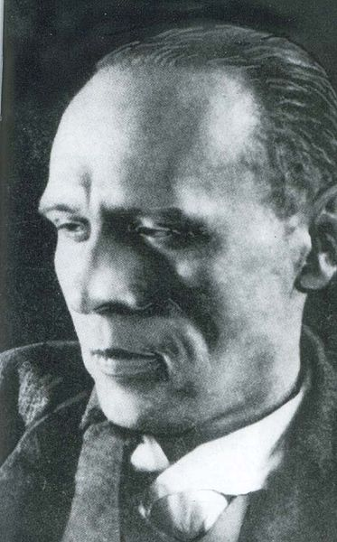

**References and Further Reading**:

Cornwall Neil, ed., *Daniil Kharms and the Poetics of the Absurd.* London, Macmillan, 1991.

Valuable collection of essays and materials. A good place to start.

Mikhail Iampol’skii, *Bespamiatstvo kak istok (chitaia Kharmsa)*. Moscow: Novoe literaturnoe obozrenie, 1998.

*Sophisticated reading of Kharms focusing on his philosophical and cosmological concerns*.

John-Philippe Jaccard, *Daniil Harms et la fin de l’avant-garde russe*. Bern: Peter Lang, 1991.

Kharms and Russian avant-garde of the 1920’s. Fundamental.

Branislav Jakovljevic, *Daniil Kharms: Writing and the Event*. Evanston: Northwestern University Press, 2009.

Kharms’s work as metafiction. Stimulating.

Aleksandr Kobrinskii, *Daniil Kharms*. Moscow: Molodaia gvardiia, 2008.

Deeply-informed “Life and works” biography.

Graham Roberts, *The Last Soviet Avant-Garde: OBERIU – Fact, Fiction, Metafiction.* Cambridge: Cambridge University Press, 1997.

Comprehensive study of OBERIU authors and poetics

Susan Scotto, “Xarms and Hamsun: *Staruxa* Solves a Mystery?” *Comparative Literature Studies* 23 (1986): 282-96.

Details connections between “The Old Woman” and a Hamsun novel.

Valerii Shubinskii, *Daniil Kharms: Zhizn’ cheloveka na vetru*. Saint Petersburg: Vita Nova, 2008.

Well-documented biography, especially useful for the early years.

Elena Sokol, *Russian Poetry for Children.* Knoxville: The University of Tennessee Press, 1984.

Kharms as children’s author.

Alice Stone-Nakhimovsky, *Laughter in the Void: An Introduction to the Writings of Daniil Kharms and Alexander Vvedenskii*. Vienna: Wiener Slavistischer Almanach, 1982.

Pioneering study of the works of the two authors. Still useful.

**Works**:

*Dnei katybr: Izbrannye stikhotvoreniia, poemy, dramaticheskie proizvedeniia.* Ed. M. Meilakh. Moscow-Cayenne: Hylea, 1999.

*Polet v nebesa.* Ed. A. Aleksandrov. Leningrad: Sovetskii pisatel’, 1988.

*Polnoe sobranie sochinenii*. Ed. V. Sazhin. Saint Petersburg: Akademicheskii proekt, 1997-2002.

.

*«Sborishche druzej ostavlennykh sud'boiu»: A. V. Vvedenskii, L. Lipavskii, Ia. Druskin, D. Kharms, N. Oleinikov: «chinari» v tekstakh, dokumentakh i issledovaniiakh*. Eds. V. Sazhin, A. Dmitrenko et al. 2 vols. Moscow: Ladomir, 1998.

*Sobranie proizvedenii.* Eds. M. Meilakh and V. Erl’. Bremen: K-Presse, 1978-88.

*Sobranie sochinenii.* Ed. V. Sazhin. Saint Petersburg: Azbuka, 2011.

*The Blue Notebook.* Trs. M. Yankelevich. NY: Ugly Duckling Press, 2005

*“I am a Phenomenon Quite Out of the Ordinary”: The Notebooks, Diaries, and Letters of Daniil Kharms.* Trs. A. Anemone and P. Scotto. Boston: Academic Studies Press, 2013.

*Incidents.* Trs. N. Cornwall. NY: Serpent’s Tail, 1993.

*OBERIU: An Anthology of Russian Absurdism*. Ed. E. Ostashevsky. Evanston: Northwestern University Press, 2006.

*The Man with the Black Coat: Russia's Literature of the Absurd*. Trs. G. Gibian. Evanston: Northwestern University Press, 1997 (Originally published 1971).

*Today I Wrote Nothing*: *The Selected Writing of Daniil Kharms.* Trs. M. Yankelevich et. al. NY: Ardis and Overlook Duckworth, 2009.

**Peter Scotto, Mount Holyoke College**

Source url for image: https://ru.wikipedia.org/wiki/Хармс,_Даниил_Иванович